Make a Video of Support!
Videos are an invaluable way of building online momentum and buzz. Media that can go viral demonstrates the grassroots nature of our support and advocacy. Promotional videos to help get the word out about Students’ Day 2010 is also an idea!
The focus of the videos should be on the efforts and struggles of Iran’s student activists, the key issues being highlighted for Students’ Day 2010, specific student detainee cases (e.g. Majid Tavakoli or Bahareh Hedayat), or any other topic related to the basic human, civil, and academic rights that must be fully restored to Iran’s students.
You do not have to be a professional to make a video! Digital cameras, flip cams, and even cell phones are a great way to start. Some of the previously made videos received thousands of hits and went viral quickly, with some of them making their way to Iran.
Suggestions and ideas for an effective video are below. Feel free to modify your video as you see fit, this is just a starting point! Once your done, please share your video with us by sending a link to share@united4iran.org

Making the video
A very basic digital camera will do the trick. Consider filming and photographing the participants with signs, banners, or posters that 1) are easy to read 2) have a clear message and 3) clearly show student, university, or campus support of Iran’s Students’ Movement. This can easily be done by taking footage in front of your school’s signage holding something as simple as a poster reading “We Support Iran’s Students Movement!” You can also find pre-designed banners to download-and-print here. See the picture below for a great example of Carlton University students showing their support during last year’s Students’ Day.

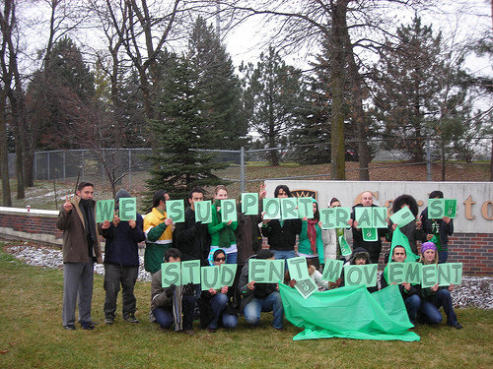

Be creative! Recognizable campus landmarks are a great way to incorporate the campus support aspect into the video. Take footage in busy areas with lots of people and high foot traffic. You can simply stand there as those walking by watch you. It can be a uncomfortable to be openly stared at, but the visual impact will be great! Wearing masks while taking footage is also an easy and effective way to increase the intensity of the visual message. You can find some easy-to-print masks of various students here.

Including tile-printed posters
A really easy way to get involved and increase the visual impact of your visuals is by making tile-style banners & posters by printing dozens of pages on a home printer to make one large banner/poster. Publically assembling the tile-printed posters at your event or during filming can be an effective action as well. Whatever you do, try and remember the goal is to personalize and support Iran’s students’ movement front and center! See an example video of putting together a tile-printed poster of prominent student activist, Behrouz Javid Tehrani.

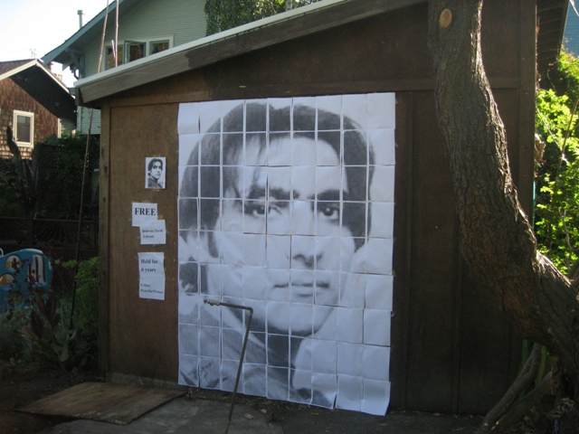

You can easily upload any picture and render it into a tile-printed poster here: http://homokaasu.org/rasterbator/wizard.gas?Phase=1

<object width="425" height="344"><param name="movie" value="http://www.youtube.com/v/HYXZvGdN9ZE?fs=1&amp;hl=en_US"></param><param name="allowFullScreen" value="true"></param><param name="allowscriptaccess" value="always"></param><embed src="http://www.youtube.com/v/HYXZvGdN9ZE?fs=1&amp;hl=en_US" type="application/x-shockwave-flash" allowscriptaccess="always" allowfullscreen="true" width="425" height="344"></embed></object>

Need more help? Click here for detailed instructions.

Slides
Below are some slides you can use to promote the day and encourage participation. Each text slide should last about 1-3 seconds with no more than 6-8 words on the screen. Make sure the text is on the screen long enough to be read by a non-native speaker.

Putting it all together
Make your video short and sweet! Most people won’t sit through an eight minute video so make sure the video is no longer than about 3 minutes in length. Special effects can distract from the message. Use simple footage and simple transitions! Add a “non-distracting” music background if you want!

Done with your video?
Send the link of the uploaded file to share@united4iran.org to be posted.
Making Tile-Printed Posters
Each sheet of paper printed is a piece of the full poster (a “tile”) that, when all put together, creates a poster from the picture used. The program can make posters from any picture as big as 20 meters in size. Read below for step-by-step directions to create a tile-printed poster. You can use any type of image, picture, banner, to create your own, inexpensive tile-printed poster.

Consider pre-printing the sheets and assembling the poster in public. Putting it together is an event in and of itself. Make a video or take pictures of the poster’s assembly & finished project and send them to share@united4iran.org
Alternately, you can pre-make the tile-printed posters and tape them to boards so as to easily transport them to events.

Directions
- Choose the picture out of which you want to make a poster.
Some pictures, posters, and banners can be found here.
- Upload your picture to the tile-printing program here: http://homokaasu.org/rasterbator/wizard.gas?Phase=1
- Choose your poster size and crop the picture
In “CROP” mode, you can decide if you want your poster landscape or portrait (horizontal or vertical). You can also decide what portion of the picture you would like to use. If you want to use the whole picture, do not adjust the crop box around the picture. In “SIZE” mode, you can decide how many sheets of paper you would like to use for printing your poster. The more sheets of paper you choose to use, the bigger the poster. Posters that are between 36 (6×6) and 100 (10×10) sheets work best. When done, hit the “NEXT” button at the bottom of the screen. After hitting next, hit the “CONTINUE” button when prompted. You will be taken to the poster options page.
- Select the tile-printed poster options.
Make sure to unselect the “Draw border around area” option at the top of this page. If selected, it will draw a dim rectangle around the graphic of each page – this is useful only if you want to cut away at the paper’s empty margins. If you do not want to cut the margins, UNSELECT the option. Hit the “rasterbate” button at the bottom of the options. It will automatically render the poster.
- Download your new tile-printed poster
After the image is done rendering, you will be prompted to download a PDF file of the poster. Save the file to your computer. When you open the file, there should be as many pages as you selected, with each sheet being a piece of the entire poster. Print the poster out on any printer and use tape to assemble it!

If you have any trouble rendering posters, please e-mail us. Remember to share your video and photos of this action by sending them to share@united4iran.org!

NEED TO MAKE:
- SLIDES FOR VIDEOS
- BANNERS & POSTERS
- GALLERY OF STUDENT PICTURES
- STUDENT MASKS

